**Consider the below two tables:**

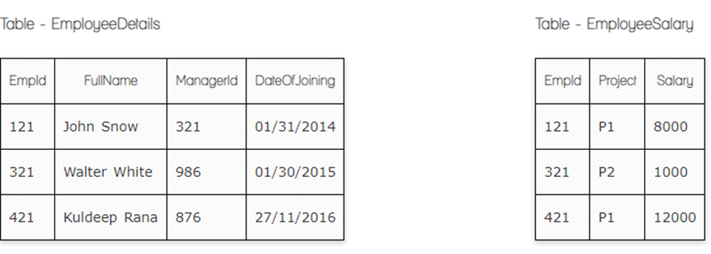

Ques.1. Write a SQL query to fetch the count of employees working in project 'P1'.

Your Answer:

SELECT COUNT (EmpId)

FROM EmployeeSalary

WHERE Project=’P1’

Ques.2. Write a SQL query to fetch employee names having salary greater than or equal to 5000 and less than or equal 10000.

Your Answer:

SELECT Fullname, Salary

FROM EmployeeDetails

INNER JOIN EmployeeSalary

ON employeedetails.empId = employeesalary.empId

WHERE employeesalary.salary >= 5000 AND employeesalary.salary <= 10000;

Ques.3. Write a query to fetch employee names and salary records. Return employee details even if the salary record is not present for the employee.

Your Answer:

SELECT Fullname, salary

FROM employeeDetails

LEFT JOIN Emlpoyeesalary

ON employeedetails.empid = employeesalary.empid;

Ques.4. Write a SQL query to create an empty table with ‘Test’ name.

Your Answer:

CREATE TABLE Test (

ID int

Empty Null

)

Ques.5. Write a SQL query to delete an empty table with ‘Test’ name.

Your Answer:

DROP TABLE Test

Ques.6. Write a SQL query to insert new record to the EmployeeDetails table with any data.

Your Answer:

Insert into Employeedetails (EmpId, Fullname, ManagerId, Dateofjoining)

Values (422, Tatevik, 990, 20/09/2023)

Ques.7. Write a SQL query to update EmployeeSalery table with setting Salary to 2000 for Project P2.

Your Answer:

Update EmployeeSalary

Set Salary=2000

Where Project=’P2’

Ques.8. Write a SQL query to right join both tables and draw the results.

Your Answer:

SELECT employeeDetails, employeesalary

FROM employeeDetails

RIGHT JOIN Emlpoyeesalary

ON employeedetails.empid = employeesalary.empid;

**Now take these two tables:**

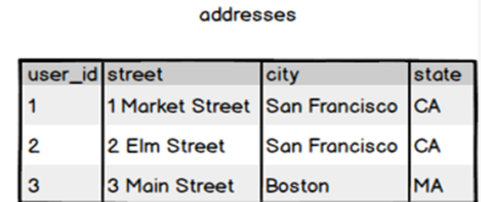

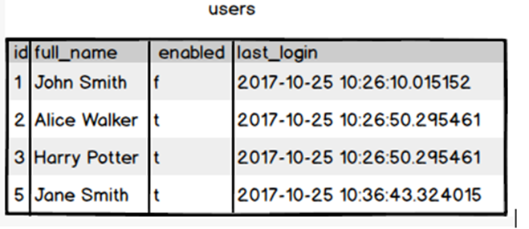

Ques.9. Write a SQL query to fetch all users full_name from San Francisco.

Your Answer:

SELECT users.full_name

From users

INNER Join addresses

On users.id=addresses.user_id

WHERE addresses.city=’San francisco’

Ques.10. Write a SQL query to fetch all users full_name who are not from Main street

Your Answer:

SELECT users.full_name

From users

INNER Join addresses

On users.id=addresses.user_id

WHERE NOT addresses.street=’Main’